**Customer Flow:**

1. User Signs up in the portal:

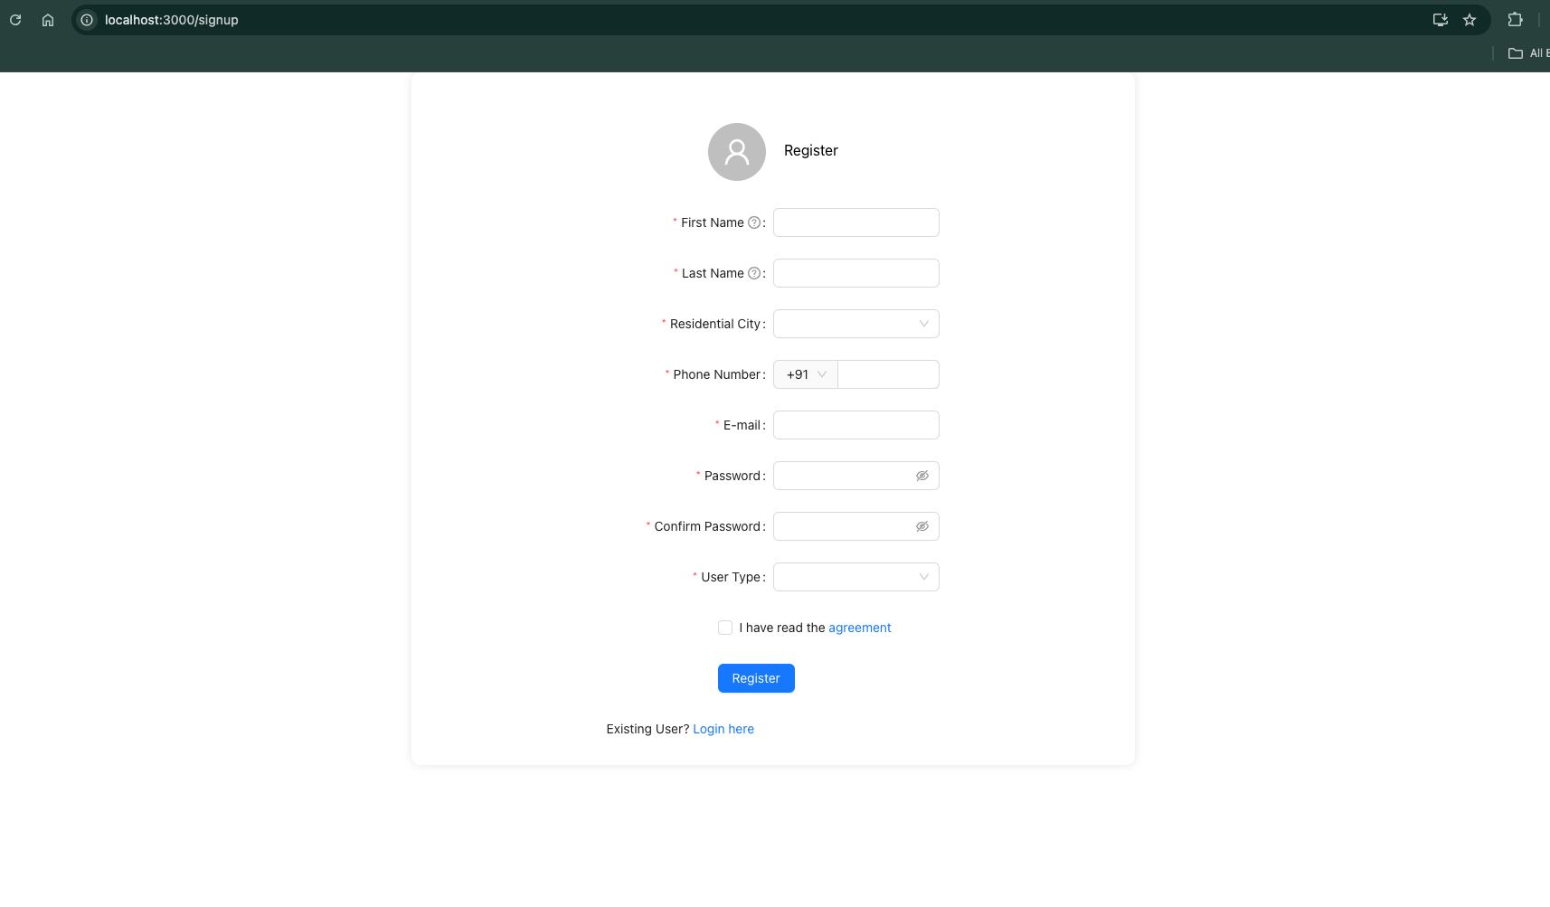

1. User Logging in to the portal:

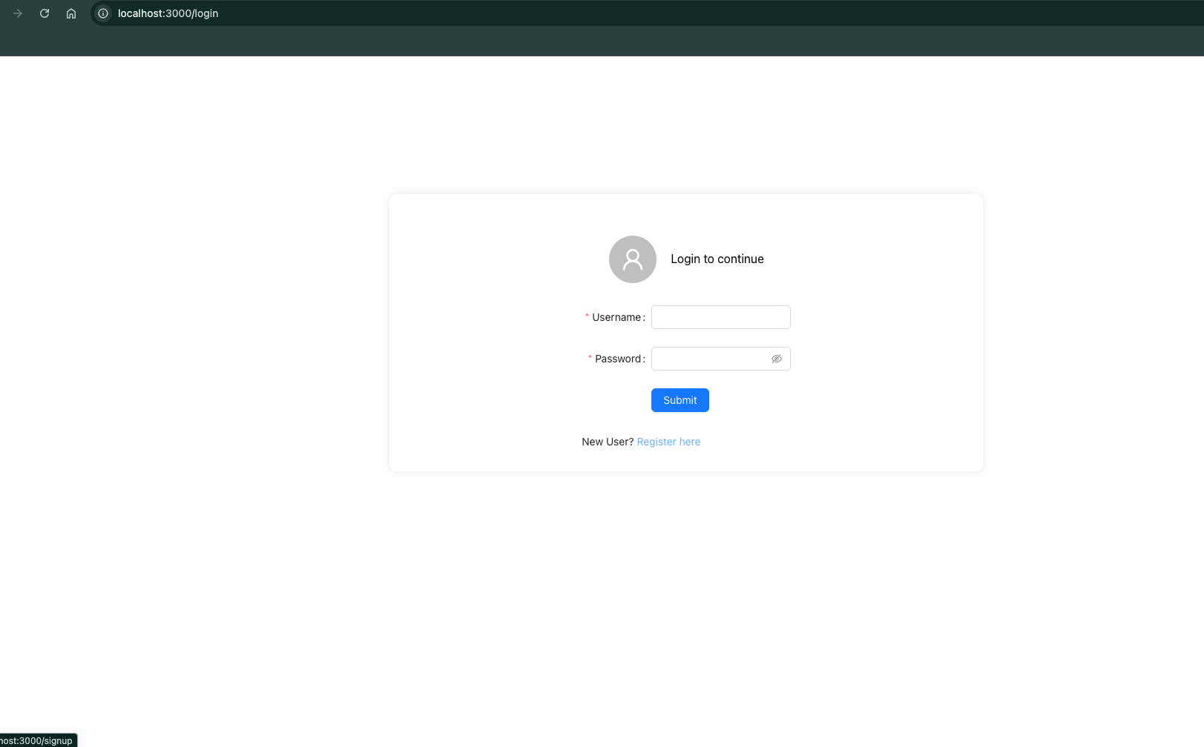

1. User Registers his car in the portal:

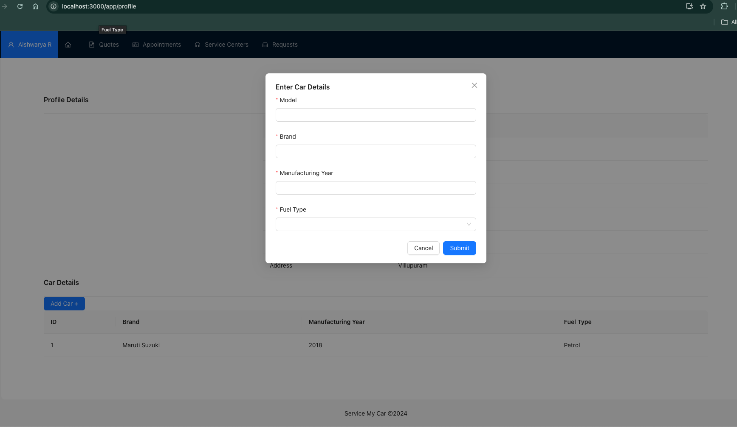

1. Breakdown button to trigger breakdown alert to registered service centers nearby that area.

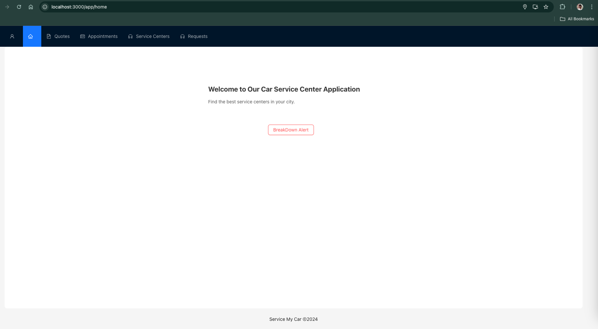

1. Request Quotation in the quotation page from service centers.

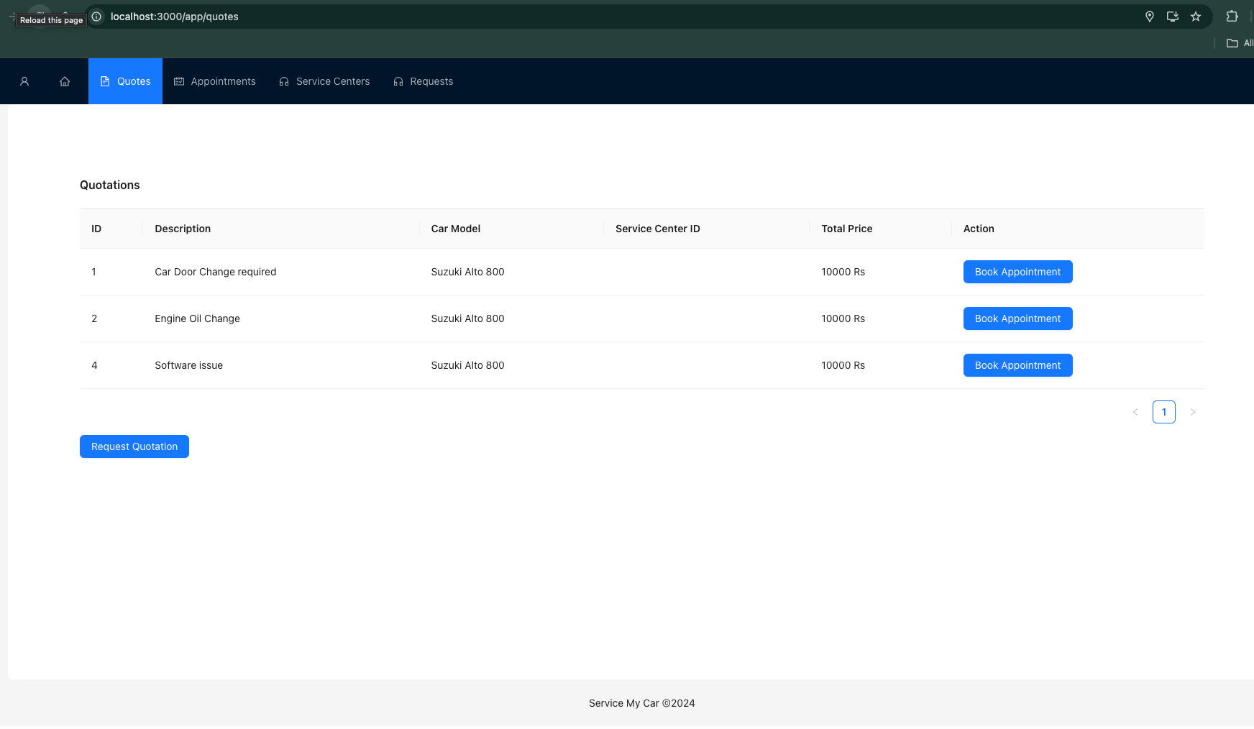

1. An email alert sent to service centers to propose the quotation

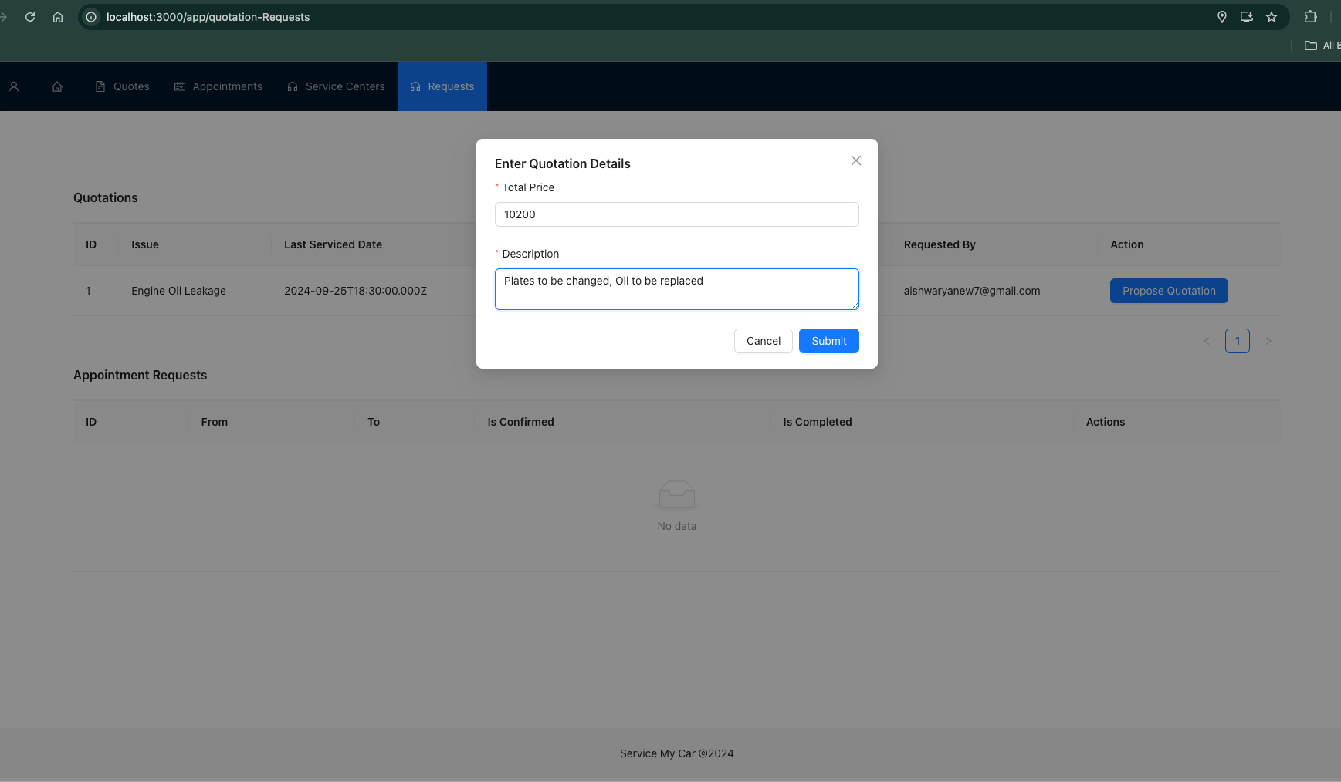

1. On Receiving the quotation, Customer chooses it and books an appointment

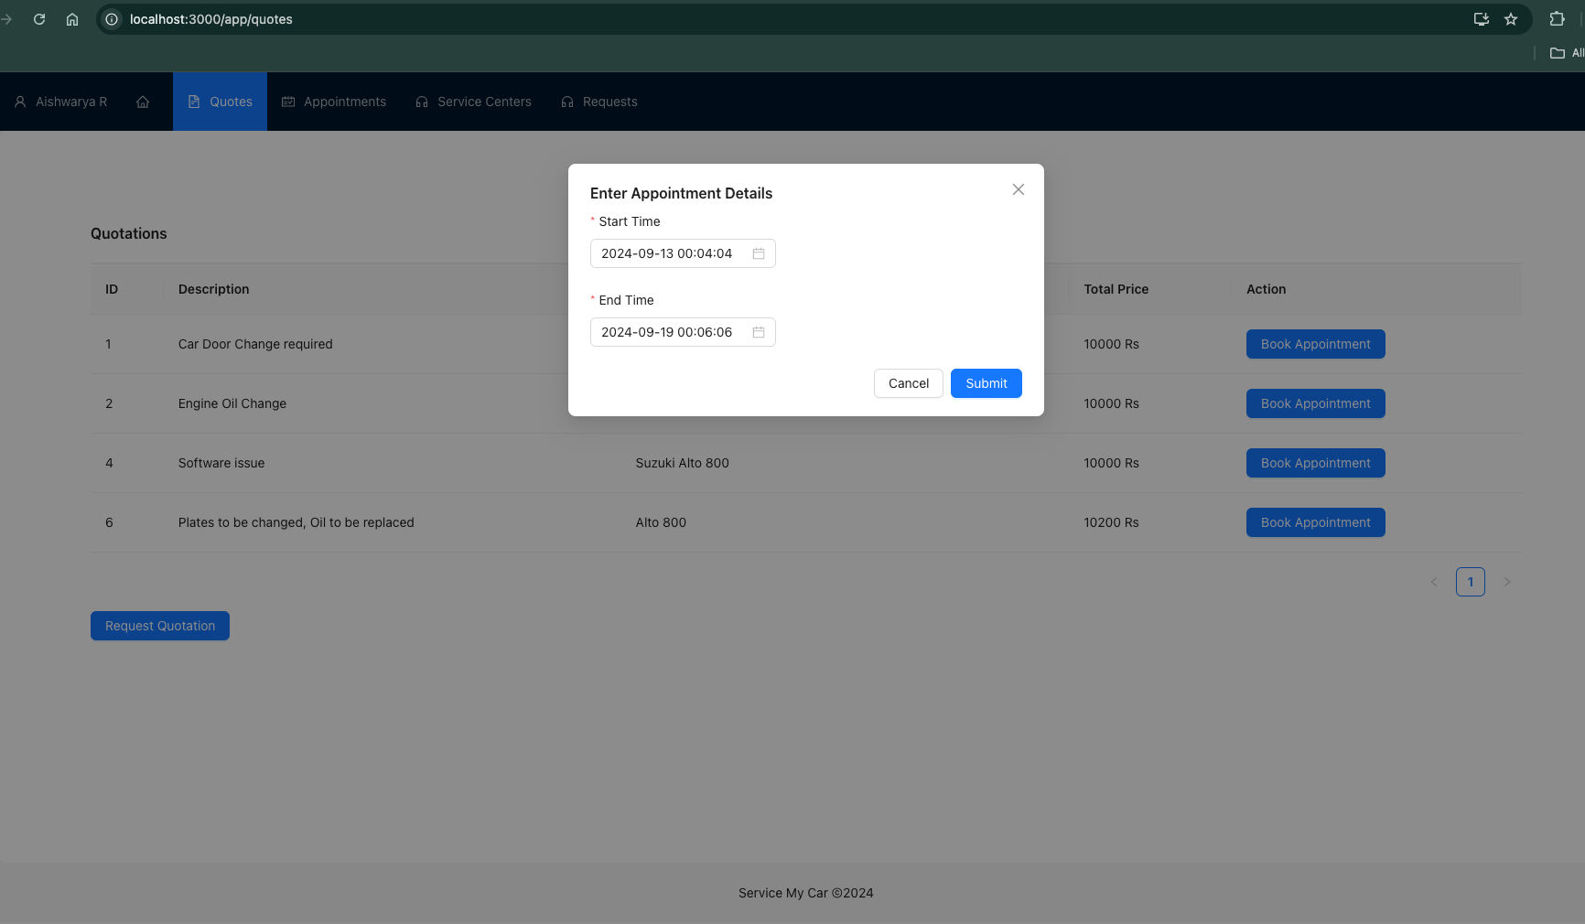

1. Service Center is notified of the Appointment and they confirms back

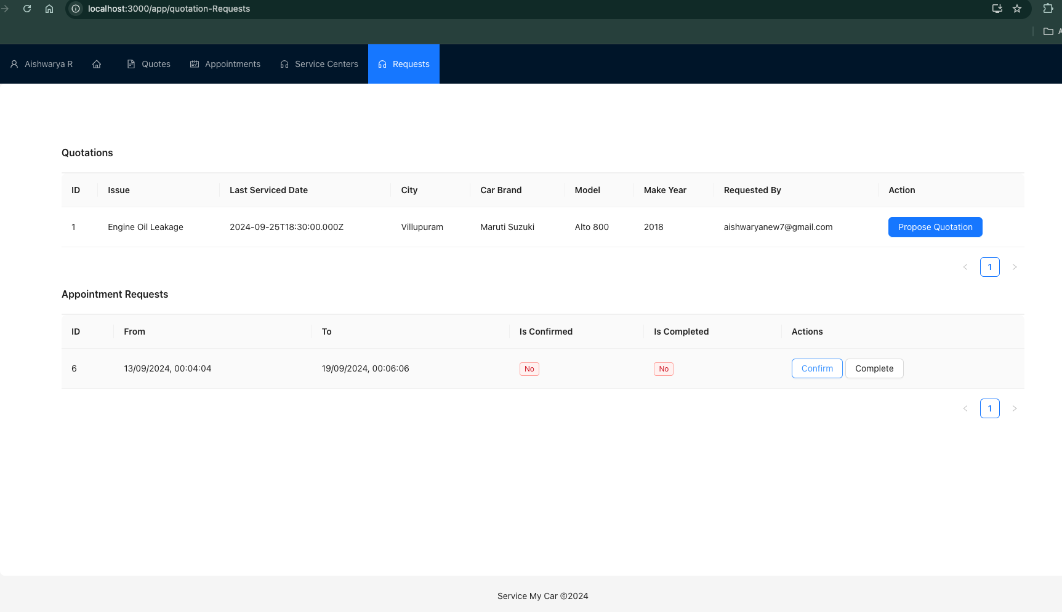

1. On confirmation user receives the notification and proceeds for service:

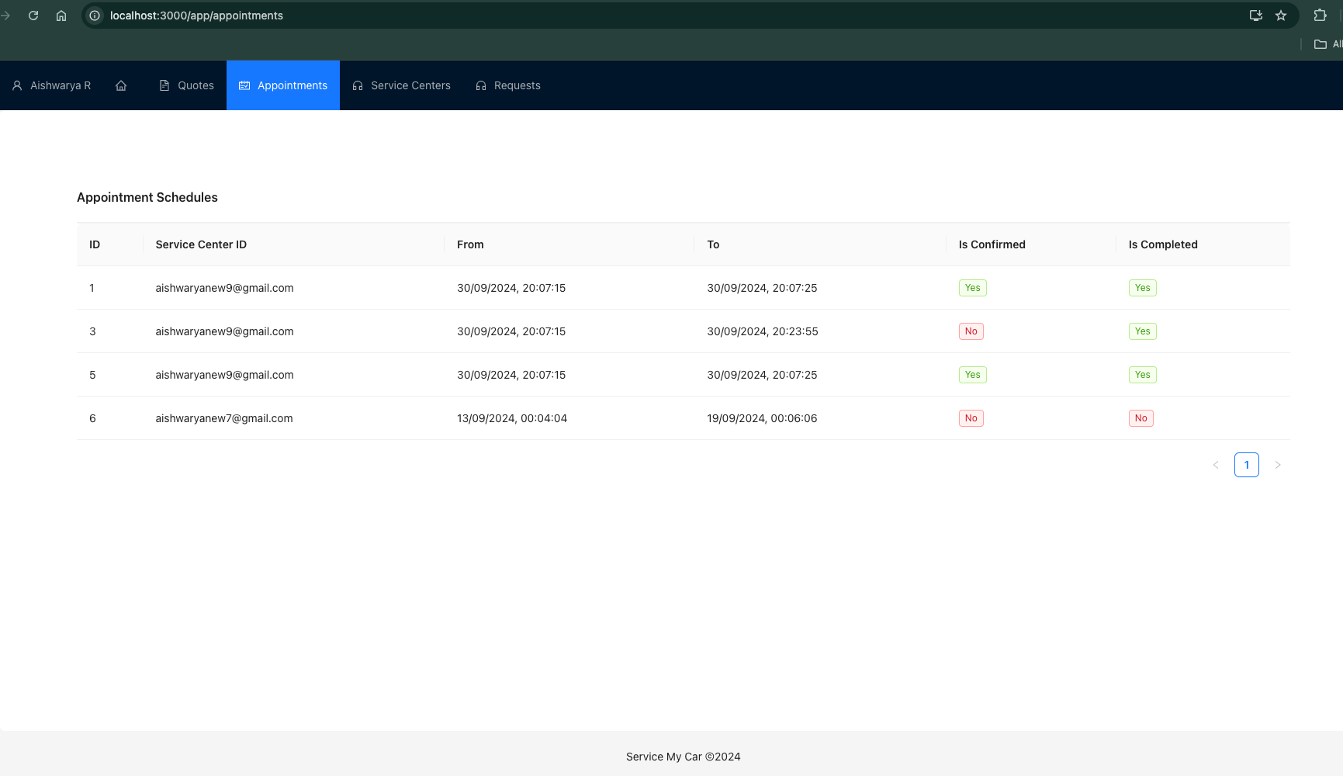

**Service Center Flow:**

1. Seller Signs up in the portal: (step 1)
2. Seller Logging in to the portal: (step2)
3. Seller Registers his service Center in the portal:

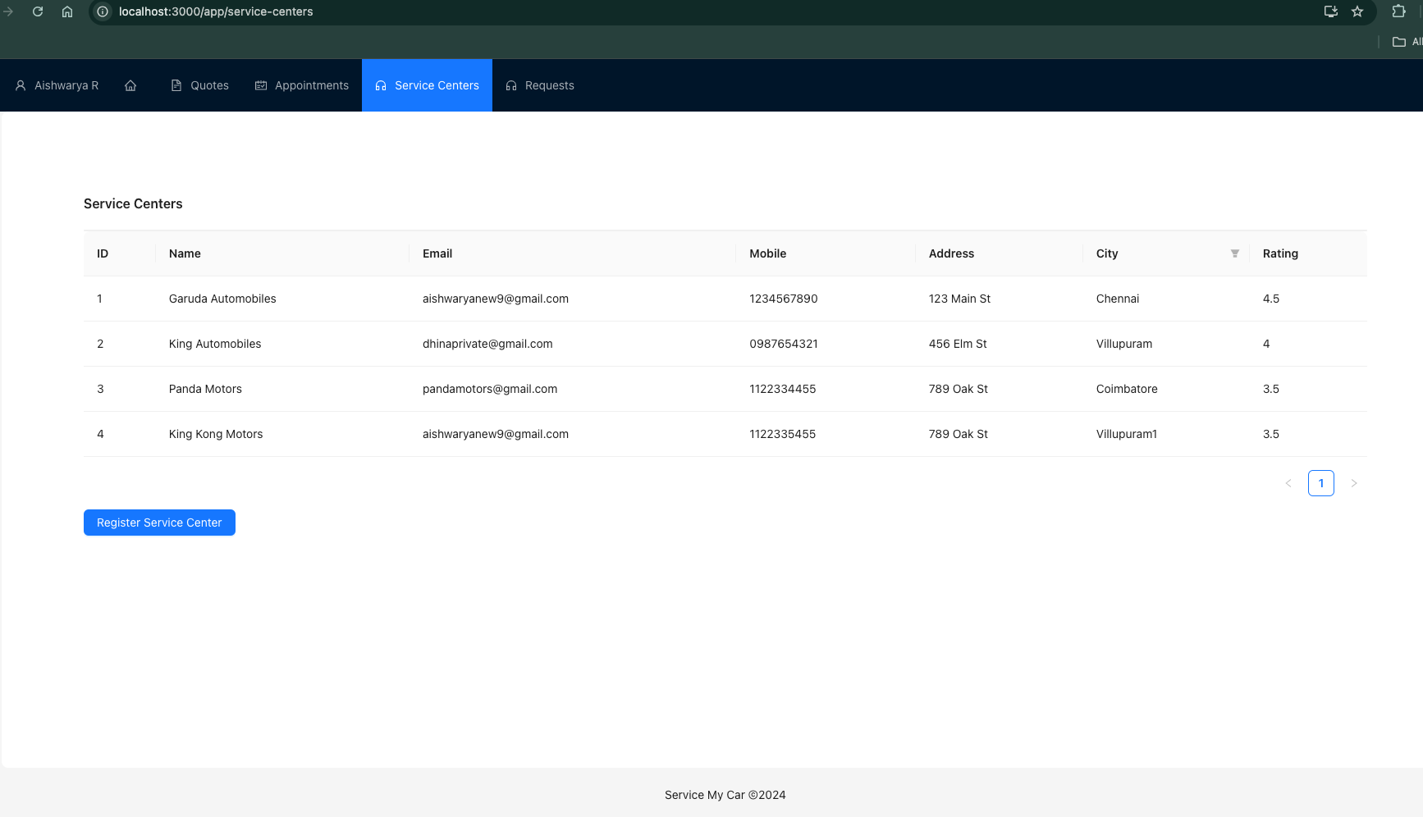

1. Propose a quotation on receiving a request from local customers (step 6)
2. On user appointment request, confirms and books the appointment. (step 8)